# Strelka CAN Testing Notes

**Strelka V2:**

It appears that Strelka V2 is transmitting CAN messages correctly. It should be noted however that they ONLY work when 5v is connected. They do not work at all if only the STLink is connected, this is because the 5v bus is not powered.

CANH

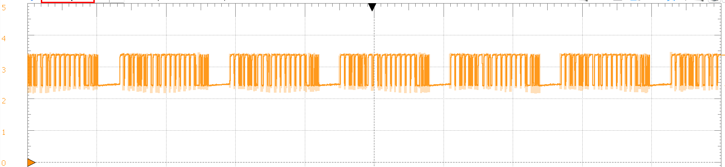

CANL

I made an interesting discovery being that the MCP2551 CAN transceiver pulls the RX pin high to ~5V. Initially, I thought this would fry the pin of the STM32H743 and STM32F407 (Strelka motor controller) however, after further inspection, it appears that these pins are 5v tolerant according to the datasheet.

STM32F407:



STM32H743:

Note the FT means 5v tolerant:

**Strelka in loopback mode:**

Strelka works in loopback mode. The transmitter can transmit from the tx fifo without errors and the rx callback occurs straight after.